How to complete a workshop application ?

Step by Step:

Instructions for Online Application System of International Training Workshops
Dear Applicants/Participants:
Before you try to start the following steps, please MAKE SURE You've,
(1) decided to participate in a Training Workshop of the ITP program in your working/research area
(2) consulted with the coordinator about the workshop you would select to ask for the admission brochure.
Now, let’s get started!

Step 1 Open your Internet Browser. (Browsers with IE kernel are preferred)
Step 2 Type in address URL: https://168.160.11.33/student_login.aspx
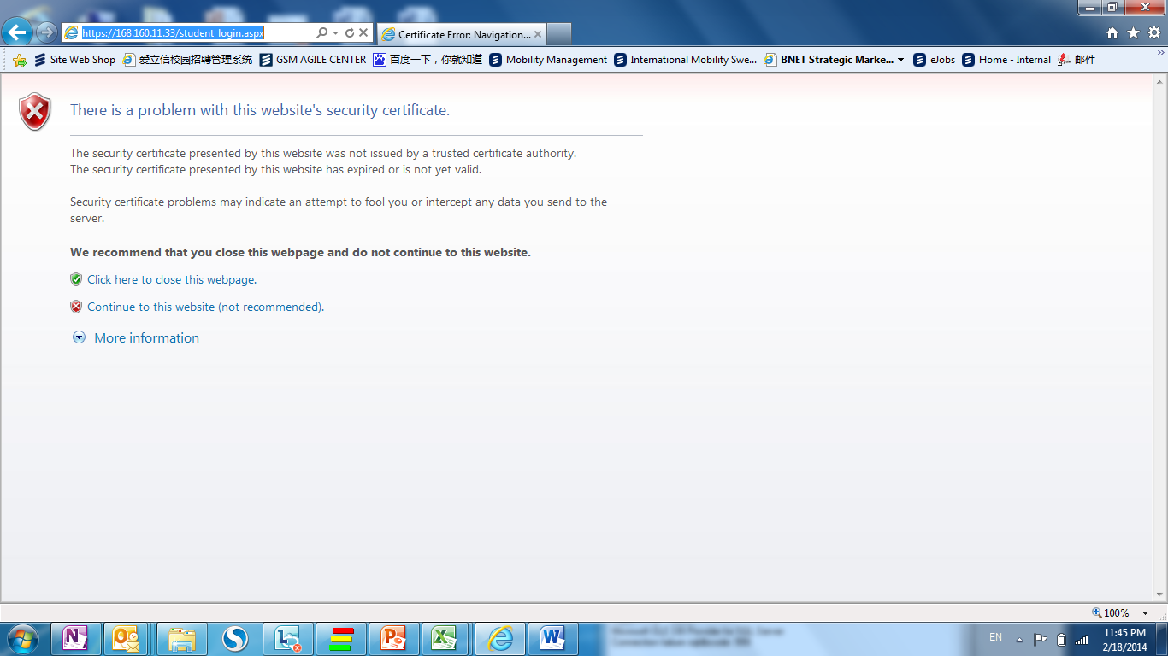
Step 3 Click “Continue to this website (not recommended)”in the reminder page.

Step 4 Select “Apply for new workshop in year 201X”. Click “Go” in the Homepage.
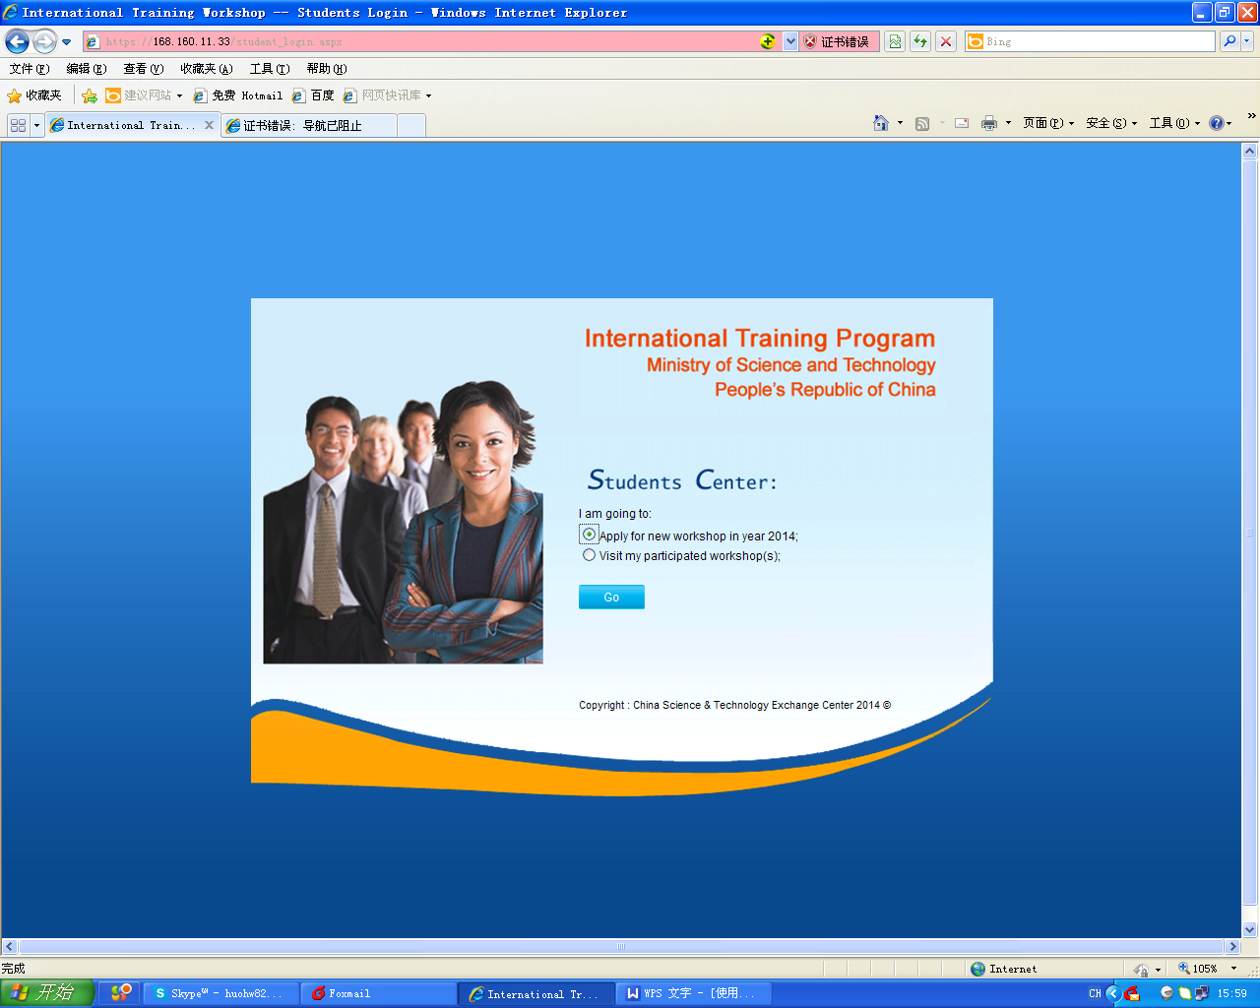
Step 5 Complete Application Step1. Choose your “Current Nationality”, input “Surname”, “Given Name” and “Passport Number”. Click “next”.
Note: All the information should be completely consistent with your passport information. E.g. Surname: TEST, Given Name: TEST1, Passport Number: G11111111.
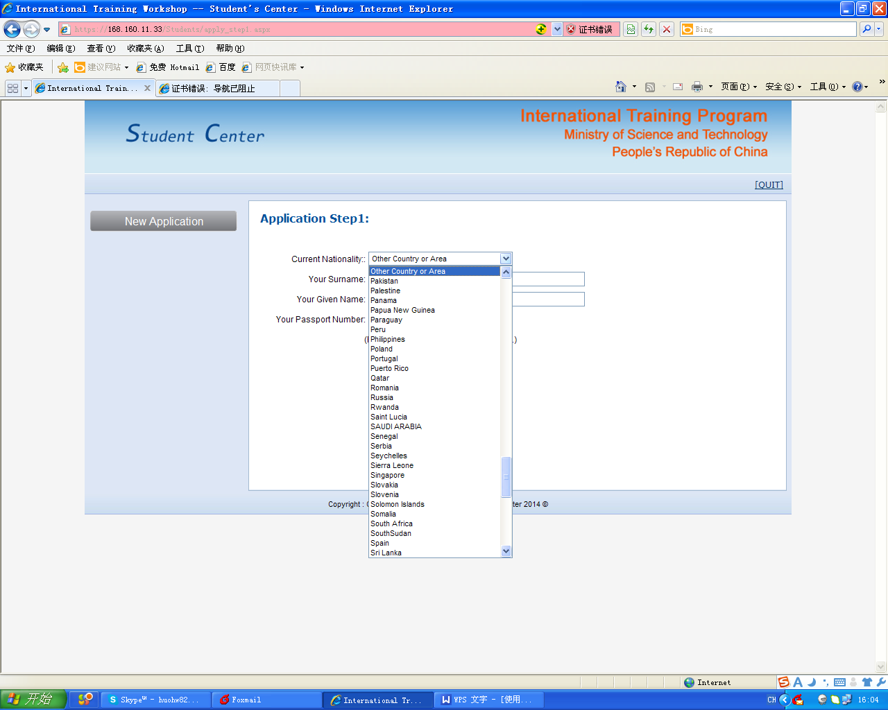
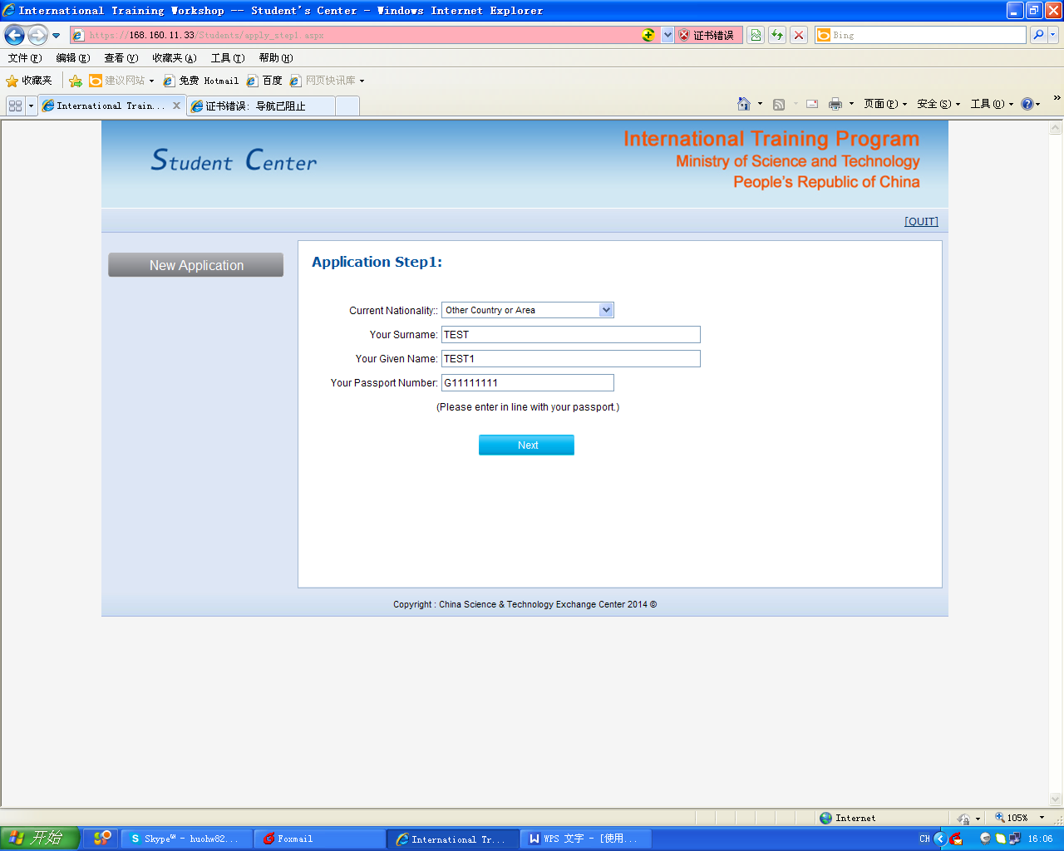
Step 6 Complete Application Step2. Fill in your information in the blanks.
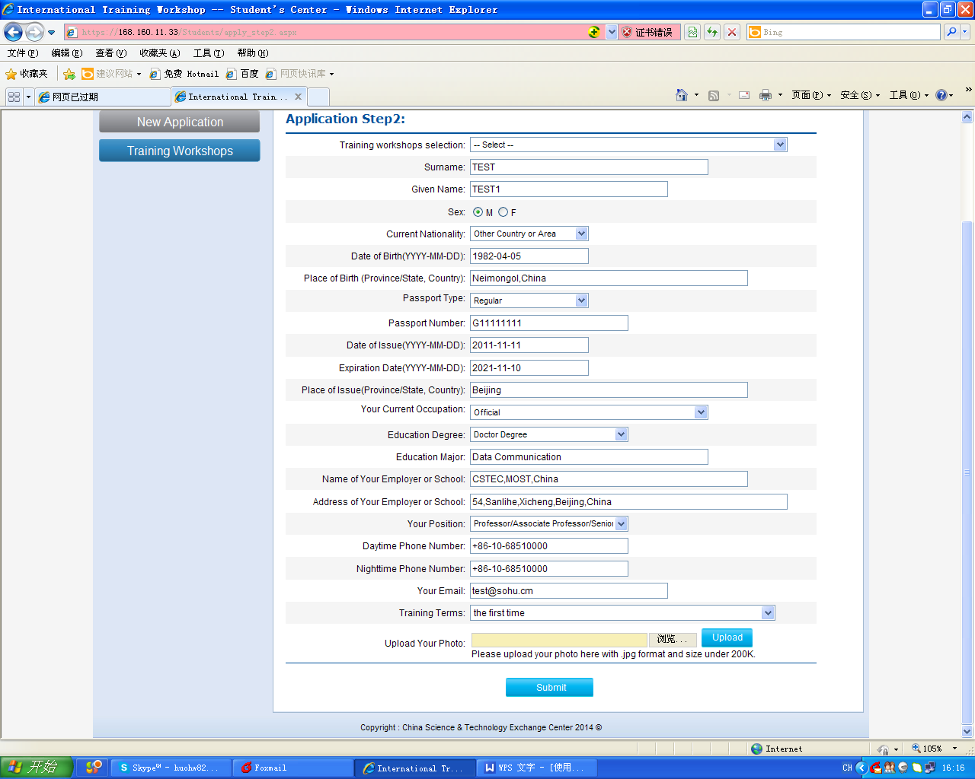
Select the workshop you consulted in “Training workshops selection”.
NOTE: Each applicant is only allowed to participate in one training workshop within one year.
When you complete all the blanks, click “Browse..” and upload your photo.
Photo size: small 2-inch (48mm × 33mm) face colored photo, and picture size should be less than 200kb.（only accept .jpg format.）
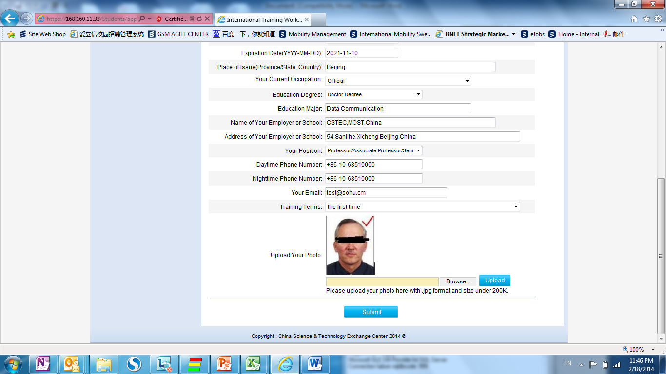
After completing the operation above, Click “submit”, and you will see “Your application has been submitted successfully.” on the page STEP3.
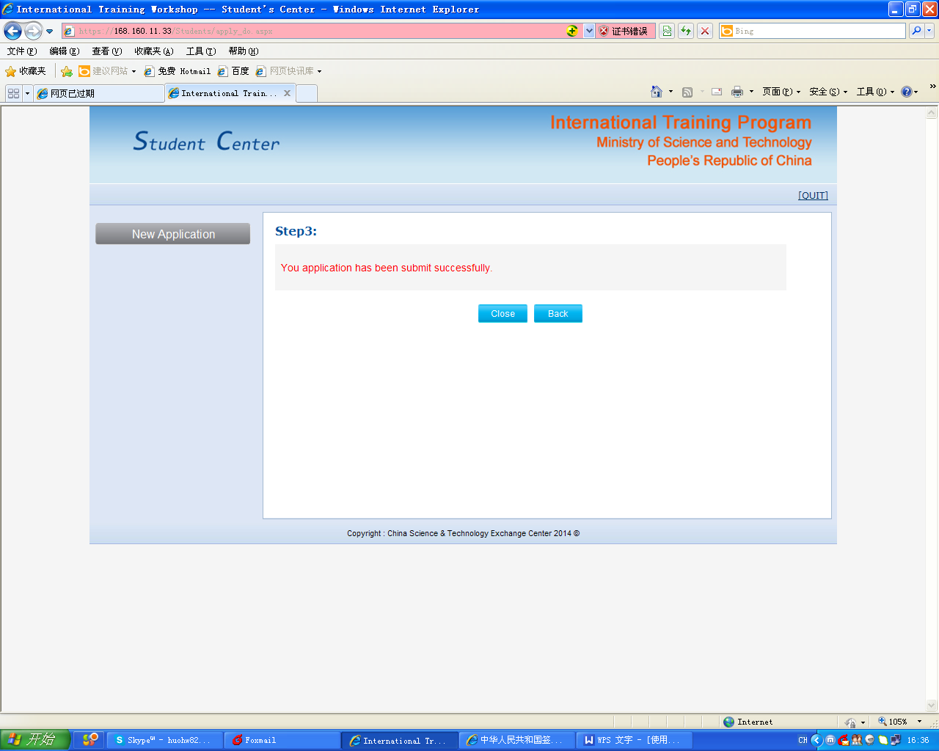
Congratulations!
You have completed the application and registration process. To protect your personal information, please be sure to click “Close” or “QUIT” to exit.
We recommend that you contact corresponding Chinese organizers again via E-mail to remind them of your completion.
PLEASE Log onto this website regularly to check your application status.

How to check your application status ?
Step 1 Open your Internet Browser. (Browsers with IE kernel are preferred)
Step 2 Type in address URL: https://168.160.11.33/student_login.aspx
Step 3 Click “Continue to this website (not recommended)” in the reminder page.

Step 4 Select “Apply for new workshop in year 201X”. Click “Go” in the Homepage.
Step 5 Choose your “Current Nationality”, input “Surname”, “Given Name” and “Passport Number”. Click “next”.
Note: All the information should be the same with your registration information. E.g. Surname: TEST, Given Name: TEST1, Passport Number: G11111111
Step 6
If you happen to encounter the tips: “Your application has not been processed yet”, it means your application is to be processed.
If you encounter the tips: “Your application is being processed. Please wait for the result.”, it means that your application is under processing. At that time, please pay attention to your E-mail, because organizers may contact you for additional information.
If you encounter the tips: “Your application has not been accepted. You can apply for other workshops.”, it means your application has been rejected .You can try to apply for other workshops.
If you encounter the tips: “Congratulations! Your application has been accepted. You can update your contact information below:”, it means your application has been accepted .You will receive the confirmation letter by E-mail or Fax in a few days.
How to evaluate your training workshop?
Step 1 Open your Internet Browser. (Browsers with IE kernel are preferred)
Step 2 Type in address URL: https://168.160.11.33/student_login.aspx
Step 3 Click “Continue to this website (not recommended)” in the reminder page.

Step 4 Select “Visit my participated workshop(s)”. Click “Go” in the Homepage.
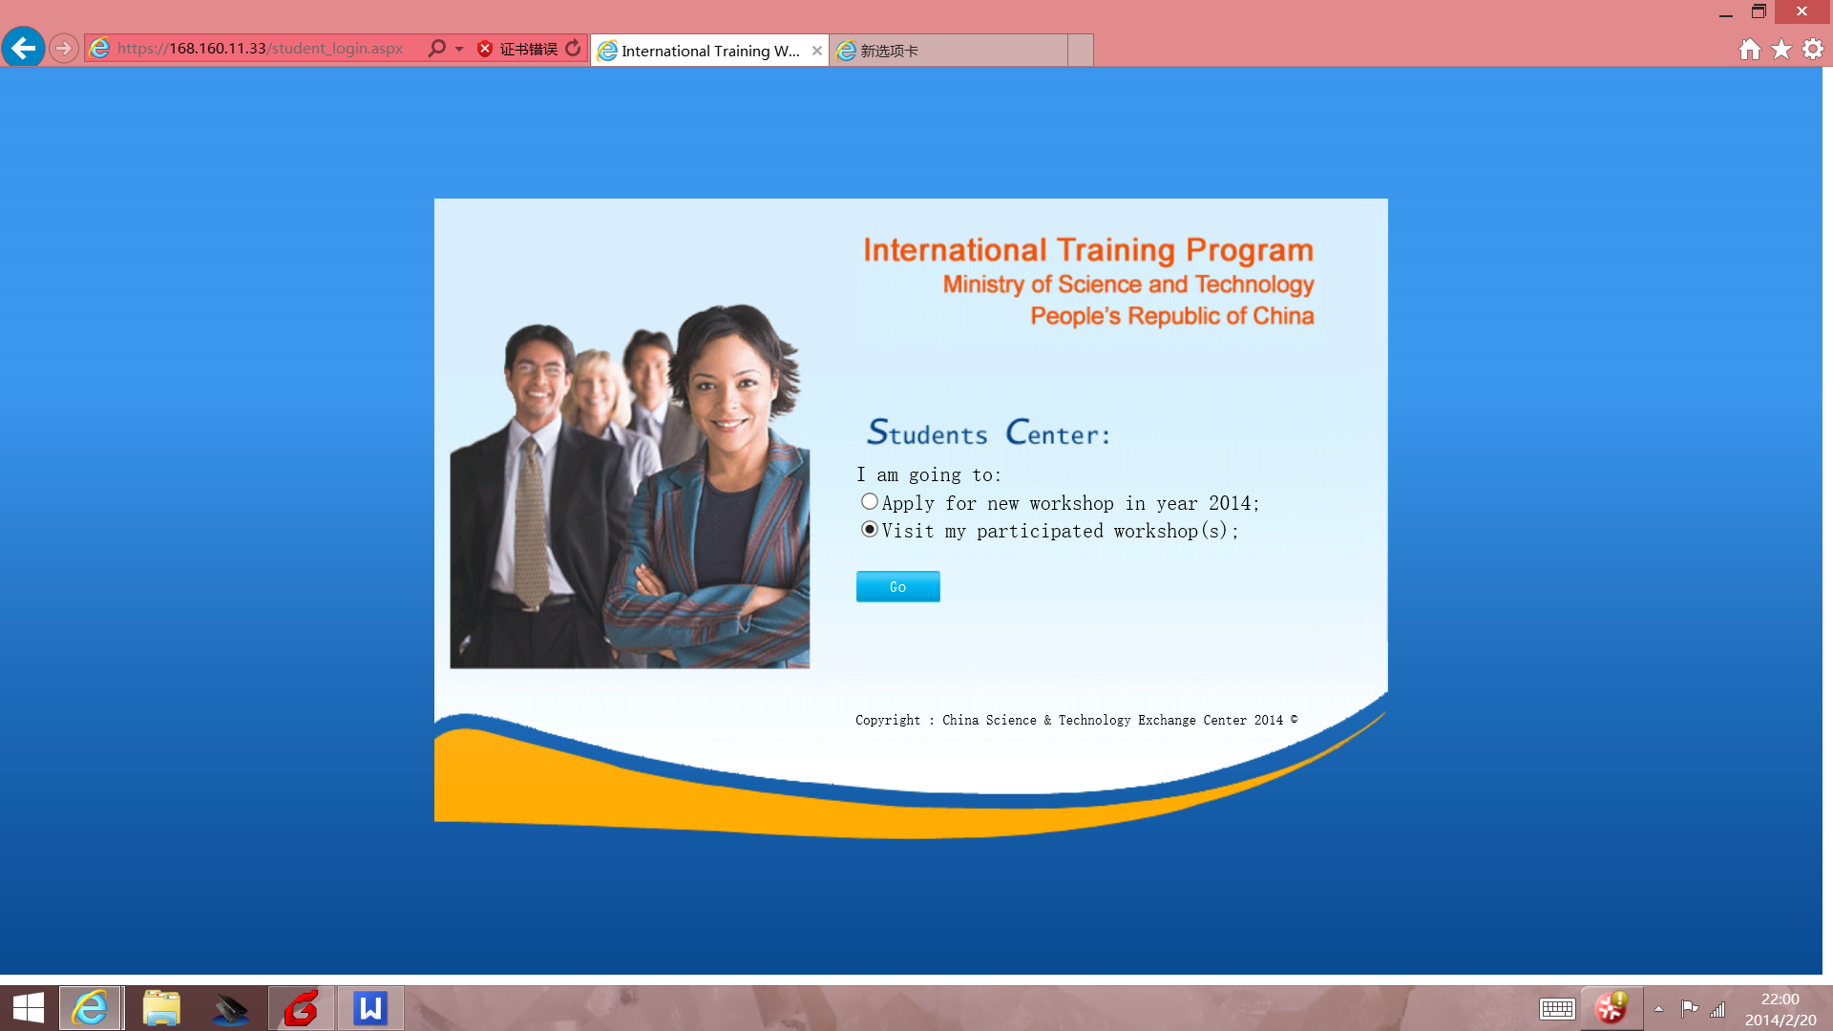
Step 5 Choose your “Training Year”, “Workshop” and “Your Study No.”, and input your “Passport Number”. Click “next”.
Note: You can get Your Study No from the contact person of your workshop organizers.

Step 6 Please complete the QUESTIONNAIRE and click “submit”.
Note: The evaluation was back to back. After clicking “submit”, neither workshop organizers nor governing bodies are able to match your comments with your real name.

After returning to your home country, you can also visit this website at any time to check the information about other participants, update your personal information to keep in touch with others. (Select “Visit my participated workshop(s)”, choose your “Training Year”, “Workshop” and “Your Study No.”, and input your “Passport Number”. Click “next”.)
